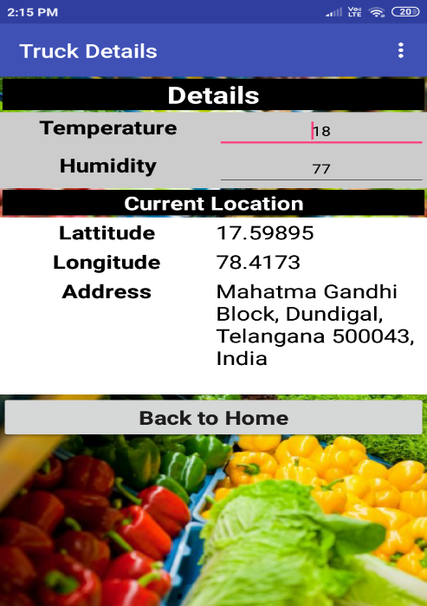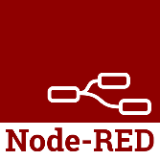

**Mobile app (MIT App**)

**IBM CLOUD**

**Data Receiver**

**NodeMCU**

**NRF Module**

**NodeMCU**

**NRF Module**

**DHT11 Sensor**

**Truck**